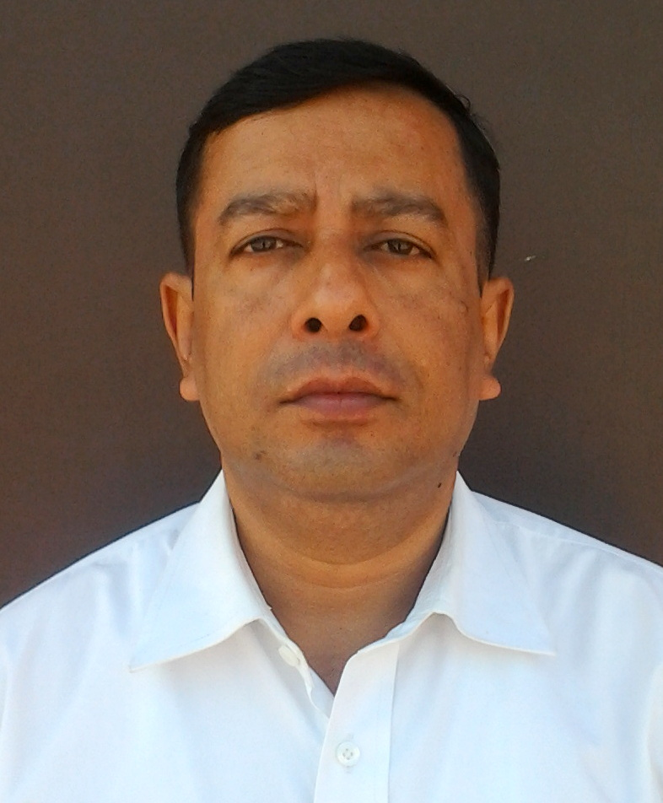
Gaurab Banerjee

Mobile: +91 8477095000. E-mail: gaurab.banerjee390@gmail.com

Objective

- To achieve the target of the assigned mission by challenge, utilizing the abilities developed through experience gathered in a disciplined organization on my merit and to upgrade and promote the growth of an organization in a stipulated time frame.

Core Competencies

Operations/ General Management/ Administrative Duties | - Managing diverse operations encompassing new unit set up, turnaround management & growth.  - Managing operations for units including Front Office, Time Office, Security Management, Housekeeping, Fire System, and to ensure high quality of operating standards.  - Imparting appropriate in house training to the workers and staff so as to attain work excellence & teamwork.  - Developing relations and coordinating with Govt. bodies, Station Fire Office etc.  - Able to adapt to changing environment.  - Managing the requirements and expectations of the most discerning international and local guests.  - Capable of maintaining a positive outlook and working well whilst under pressure.  - Possess excellent guest relationship skills in establishing the immediate rapport with international and local buyers/ customers.  - Flexible and proactive problem solver.  - Excellent communication skills, has the ability to develop close and effective communications.
People Management/Training | - HRM, Staffing, Recruitment, Performance Review and Appraisal.  - Handling operational functions like pre-shifts staff briefings, creating the duty roster, shift management.  - Conducting training classes, constant adaptability to change in facility trend through constant innovation, ready to take additional responsibility and challenges.


Admin, HR, Compliance Manager in Global Footwear Agra from 01 July 2013 to Till Date.

Responsibilities
- Established the new factory from all point of view including construction, interiors& installation of machineries.

- Second in command in the factory and overall in charge of all the departments viz: Time office, Front Office, Housekeeping, Security, General maintenance & Services, Horticulture, Internal & External audits, Fire fighting systems, Interiors, Welfare of workers and First Aid of workers. Handling of contractual Security and CC tv monitoring of housekeeping activities and safety.
- Prepare project team, monitoring, assisting in installation and coordinating the training of Operations staff on various quality aspects. Performing internal audits for SA 8000 and ISO 9001 for the system certifications.
- Attending all the seminars related to Social Compliances (SA 8000) & Quality audit (ISO 9001).
- Organizing Management Review Meetings and documentation time to time on periodic basis.
- Experience of over 05 years, with exposure to identifying and sourcing factory operating equipment and supplies, work on pre opening of factory outlet and generation of revenue & manpower recruitment, identifying and writing SOPs, designing and finalization of guest and buyers collaterals, project progress review on regular basis, day to day coordination with brand team and owners representatives, snagging of floors of the factory, public and back of the in-house areas and facilities, systematic take over from health and environment concern.
- Organizing the training for Fire fighting, SA 8000, ISO 9001, Health & Safety and to coordinate the workers committee meeting, first aid training, harassment committee meeting etc. Liaising with Government authorities, Fire departments, Auditors for the smooth running of the factory.
- Attending and managing all internal, external, and third party audits. Surprise checks of the factory in night hours and holidays.
- Organized conferences/in-house events, traveling schedules and hotel reservations for senior management & Auditing bodies.
- Conduct Direct and indirect regular reviews with HODs to ensure that audit targets are met.
- Coordinating among the departments for collecting various reports and information for staff and facility managing activities.
- Communicates effectively with all levels of employees.

  - Admin, HR, Compliance Manager, from 01 May 2008 to 30 May 2012

R N Bajaj Overseas, Agra
www.rnbajaj.com

Responsibilities

- Second in command in the factory and overall in charge of all the departments viz: Time office, Front Office, Housekeeping, Security, General maintenance & Services, Horticulture, Internal & External audits, Fire fighting systems, Interiors, Welfare of workers and First Aid of workers. Handling of contractual Security and CC tv monitoring of housekeeping activities and security.
- Prepare project team, monitoring, assisting in installation and coordinating the training of Operations staff on various quality aspects. Performing internal audits for SA 8000 and ISO 9001 for the system certifications.
- Attending all the seminars related to Social Compliances (SA 8000) & Quality audit (ISO 9001).
- Organizing Management Review Meetings and documentation time to time on periodic basis.
- Experience of over 05 years, with exposure to identifying and sourcing factory operating equipment and supplies, work on pre opening of factory outlet and generation of revenue & manpower recruitment, identifying and writing SOPs, designing and finalization of guest and buyers collaterals, project progress review on regular basis, day to day coordination with brand team and owners representatives, snagging of floors of the factory, public and back of the in-house areas and facilities, systematic take over from health and environment concern.
- Organizing the training for Fire fighting , SA 8000, ISO 9001, Health & Safety and to coordinate the workers committee meeting, first aid training, harassment committee meeting etc. Liaising with Government authorities, Fire departments, Auditors for the smooth running of the factory.
- Attending and managing all internal, external, and third party audits. Surprise checks of the factory in night hours and holidays.
- Organized conferences/in-house events, traveling schedules and hotel reservations for senior management & Auditing bodies.
- Conduct Direct and indirect regular reviews with HODs to ensure that audit targets are met.
- Coordinating among the departments for collecting various reports and information for staff and facility managing activities.
- Communicates effectively with all levels of employees.

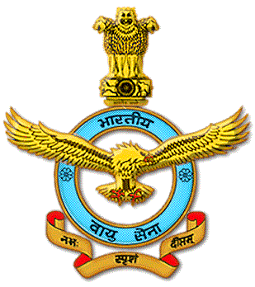
  - Senior Non Commissioned officer (AME) since 29th April 1988 to 30th Apr 2008,

Responsibilities

- Handling of Digital and Analog Aviation test equipments.
- Handling of different electrical aided testers & calibrators.
- Independent analysis of normal to typical faults of instrument systems of aircraft like AN-32, IL-76, IL-78.
- Supervisory checks of different scheduled & periodic servicing of Avionics system from 1990 to till date.
- Inventory control, man power management, & tool crib management as an in charge.
- Planning & execution of given task & making feedback reports/returns and supervision for last seven years.
- Handling the security of Information, men and material.
- Testing of Reductor of MI-8 Helicopter Test Bed Maintenance in 3 BRD, AF from 1990-1992
- AI-20 D Aero Engine of AN-32 AC Test Bed maintenance in 3 BRD, AF 1993-1996
- First Line Servicing of AN-32 Aircraft in 12 Sqn, AF from 1996-2000
- Servicing and Supervision of AN-32 Aircraft in 10 Wing, Jorhat from 2000-2004
- Second Line servicing of IL-76 and IL-78 aircraft in 78 Sqn and 4 Wing AF from 2004-till date
- In charge of Technical Control Room in IL-78 Tech Flight from 2005.

Professional Qualification:
- Diploma in Instrumentation Engineering (AICTE) from Electrical and Instrumentation Training Institute, Bangalore, IAF (1988-1990)
- Junior Management Course from Air Force Station Jorhat (2001)
- Internal Auditor Course (OHSAS – 18000 : 2007)

Aviation Courses from IAF:

- MCF of AN-32 Aircraft from 3 TETTRA Air Force Station Barrackpore ,Kolkata
- MCF of IL-76 Aircraft from 11 TETTRA Air Force Station Agra
- MCF of IL-78 Aircraft from 11 TETTRA Air Force Station Agra

Academic‘s:

- Graduation
- Industrial Security Officer Course
- Internal Auditor Course OHSAS – 18001 : 2007

Interests:

Tours and Travels, Playing Table Tennis and Billiards.

Achievements:

Participated in an International Joint Military Exercise (EX-SINDEX 06/03) with Royal Singapore Air Force in Singapore to ferry out Jaguar Aircrafts as Air-to Air refueling Crew ofIL-78 aircraft.

Key Skill
Factory establishment.

Self Appraisal:
Challenging environments and executing ability to complete any task by good public relation and inter personal communication. Leadership quality as a team leader with high motivation and extraordinary level of resource management competence with integrity.

Personal Details:

Name : Gaurab Banerjee
Fathers Name : Siddeshwar Banerjee
Date of Birth : 06 Sep 1967
Sex : Male
Marital Status : Married
Nationality : Indian
Religion : Hindu
CTC Last Drawn : Rs. 60000/- Approx.
Salary Expected : Negotiable
Reason for leaving : For better opportunity and growth for future.
Minimum joining time Reqd. : 10 days
CTC Expectation : Rs 65000/- Approx.

Declaration:

I furnish that the above mentioned information’s are true to the best of my knowledge.

Place: Agra (Gaurab Banerjee)
Date: 01 Aug 2015

